World Book Day 2017

Thursday 2nd March

On World Book Day (Thursday 2nd March), children may come to school dressed as their favourite book character, author or even a book! This is a great chance to talk about other ideas and share your own favourite characters.

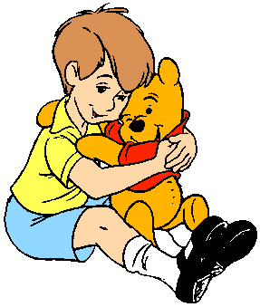Some characters are quite simple to create:

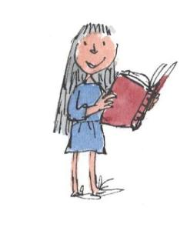Christopher Robin (yellow T-shirt, blue shorts, school shoes and a Winnie the Pooh)

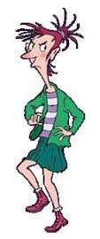Roald Dahl’s Matilda (blue dress or summer school dress and a big book)

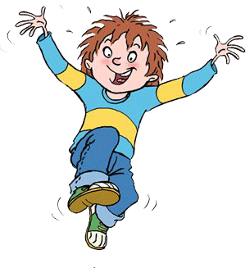

Francesca Simon’s Horrid Henry or Moody Margaret

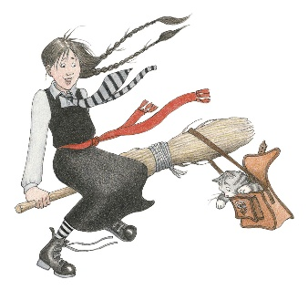

Mildred Hubble from the Worst Witch

(school pinafore, scarf around waist, tie, stripy tights and school shoes)